Here is the complete App Store Connect metadata draft for UnderCroft. You can save this text or copy and paste each field directly into your App Store Connect listing once your developer account payment clears.

App Store Metadata
- App Name: UnderCroft
- Primary Category: Lifestyle (or Utilities)
- Secondary Category: Utilities
- Support Email: support@crabkingslair.com
- Privacy Policy URL: [https://crabkingslair.com/privacy](https://crabkingslair.com/privacy)
- Support URL: [https://crabkingslair.com/support](https://crabkingslair.com/support)

App Store Listing Copy

Subtitle (30 characters max)
Estate & Digital Asset Vault

Keywords (100 characters max, comma-separated)
estate planning,digital legacy,vault,executor,will,asset tracker,family prep,secure notes,flutter,estate owner,supabase

Promotional Text (Optional — displayed above description on iOS 11+)
Securely structure and protect your digital assets, account credentials, and personal wishes for your family and executors.

Description
UnderCroft is a secure, privacy-first digital estate and legacy planning vault designed to keep your essential records organized and protected for your loved ones.
Whether managing digital accounts, detailing property assets, organizing legacy documents, or outlining personal wishes, UnderCroft provides a clean and structured space to ensure your family and designated executors have full clarity when it matters most.
Key Features:
- Digital Asset Vault: Centralize access details for accounts, documents, and certificates
- Estate & Property Documentation: Keep clear records of home, legal, and financial assets.
- Executor Access: Prepare organized guidance for designated estate representatives.
- Local Security & Privacy: Protected with biometric authentication and granular data controls.

TestFlight Information (Internal & External Beta)

Beta App Review Information
- Contact First Name: Kieren
- Contact Last Name: Pound
- Contact Phone: 07368 139355
- Contact Email: support@crabkingslair.com

Demo Account Credentials (for Apple Review)
- Username / Email: apple_review@undercroft.app
- Password: und3rcr0ft
- Notes: "This account is seeded with mock estate data."
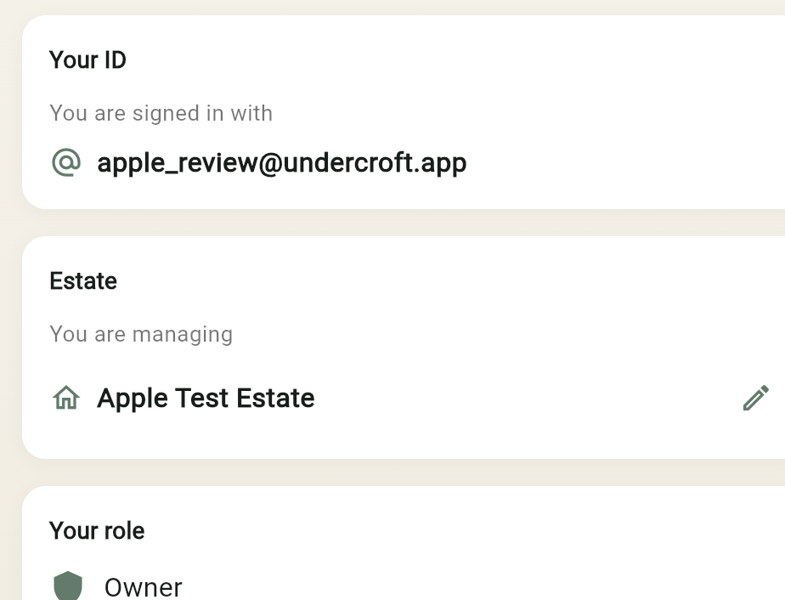

What to Test (TestFlight Beta Notes)
Plaintext
Welcome to the UnderCroft beta!

In this build, please test:
1. Creating and updating personal asset categories.
2. Unlocking and navigating the vault using Face ID / Touch ID (turn biometric on in Settings)
3. Reviewing layout clarity on modern iOS display sizes.

Please report any bugs or UI feedback directly through TestFlight, the support page (in Settings) or via support@crabkingslair.com.

Once the Apple Developer account is sorted, we can do the IAP work properly and test it in TestFlight sandbox without touching real money. That’s a much cleaner time to wire it in because we’ll have the bits that matter in place:

- App Store Connect access
- the paid app capability stack
- proper test users / sandbox flow
- no more dead ends around Apple account limits
When we pick it up, I’d suggest we do it in this order:

1. create the executor product in App Store Connect
2. wire the purchase flow in the app
3. only generate the executor code after purchase succeeds
4. handle pending / cancelled / restored edge cases properly
5. test the whole thing in TestFlight with your test estate and test executor
That should make it feel much less theoretical and much more like a real end-to-end feature.

adb uninstall com.undercroft.undercroft
adb install "build/app/outputs/flutter-apk/app-release.apk"

